**Theoretical Study of the D-T Fuel Burning Rate in Z-Pinch Facilities with Magneto-Inertial Confinement**

**Olzhas Bayakhmetov1, *, Assylkhan Azamatov1**

1 Institute of Nuclear Physics, Almaty 050032, Kazakhstan

* Correspondence: [bayakhmetov.o.s.92@gmail.com](mailto:bayakhmetov.o.s.92@gmail.com)

**Abstract:** This paper …

**Keywords:** nuclear fusion, D-T fuel, Z-pinch, reaction rate, density, temperature

**Introduction**

Nuclear fusion is a process of the collision of light nuclei with the further formation of one or more heavier nuclei and subatomic particles [1], characterized by the release of a substantial amount of energy. As is known, this process is currently of high significance for humanity due to its potential to become a clean, safe and abundant energy source in the near future [2]. At present, the sufficient number of fusion devices and projects with different fusion reactor concepts [3] exist, especially large tokamaks like the International Thermonuclear Experimental Reactor (ITER) [4] and the Joint European Torus (JET) [5], using strong and powerful magnetic fields to confine a hot plasma at temperatures exceeding 150 million °C. Although significant progress has been made in fusion research, and various fusion devices and installations are utilized nowadays, it is still unknown and uncertain when fusion reactors will finally become commercially viable. According to ITER estimations, the main D-T fusion experiments are planned for 2035, with final completion expected around 2040 [6]. It is a well-known fact that the ITER specialists expect at least a 10-fold increase in the energy of the fusion reactor, which corresponds to the production of 500 MW of fusion energy with external heating of 50 MW. Therefore, the development of nuclear fusion research and the proposal of alternative fusion reactor concepts with various methods of plasma confinement (not only tokamaks) remain one of the most crucial challenges of the current century.

The leading types of plasma confinement methods used in fusion research are magnetic confinement (JET, ITER) [7], inertial confinement (National Ignition Facility, Omega Laser Facility, Laser Mégajoule) [8], and magneto-inertial confinement (Z Facility, Tri Alpha Energy, Helion Energy, General Fusion) [3,9]. The particle density required for controlled nuclear fusion reaches 1020 m-3 in magnetic confinement fusion devices and 1031 m-3 in inertial confinement fusion devices. Both of these values can be achieved at temperatures of about 10 keV. Regarding the last concept, magneto-inertial confinement, as a new approach to energy production [3], combines the general principles of both magnetic and inertial fusion. One of the great examples is MagLIF (Magnetized Liner Inertial Fusion) experiments conducted in the Z machine at Sandia National Laboratories [10–12]. This concept involves using a Z-pinch to compress a magnetized fusion fuel [9,13–18], typically deuterium-tritium (D-T) or deuterium-deuterium (D-D), to achieve the conditions necessary for fusion reactions. Since magnetic and inertial fusion devices are well-studied, and taking into account the above statements about the commerciality of fusion reactors, Z-pinches based on the magneto-inertial fusion concept can be considered as a promising and alternative way of controlled fusion research.

Concerning the most promising types of fusion fuel, the main fusion fuel used in research and experiments is deuterium-tritium (D-T) fuel [19–21] because D-T fusion reactions release a significant amount of energy as well as occur at lower temperatures (approximately at about 10 keV) compared to other fusion reactions. Although deuterium is an abundant fuel source, it is essential to generate tritium from lithium-containing breeder blankets during neutron irradiation [22,23]. In contrast, fuel sources such as deuterium-deuterium (D-D) and deuterium-helium-3 (D-3He) can also be used in fusion reactors in the future as alternative options [24]. However, these fuel types burn efficiently at temperatures of 30 keV and above. Therefore, deuterium-tritium (D-T) remains the primary fusion fuel due to its energy yield and lower temperature required for nuclear fusion.

**Methods**

Figure 1 illustrates the scheme of the D-T fuel burning initiated by a laser pulse in a Z-pinch device. Deuterium-tritium gas mixture is contained in a cylindrical capsule under a high pressure. The ultrashort laser pulse is essential for a fast and effective ignition of the fuel mixture. An electron-photon converter designed with a high-Z element such as tantalum (Ta) is positioned at the left end of the capsule. This converter facilitates the conversion of a part of the energy from fast-moving electrons into a stream of bremsstrahlung photons. A powerful mega-ampere electrical pulse propagates through the system along the direction of the capsule axis. This scheme of nuclear fusion on the example of D-3He fuel was first proposed by Voronchev V.T. and Kukulin V.I. [25] and further developed by Seksembayev et al. [26]. The authors offered 9Be as a material for the capsule. However, since D-T fuel is considered in this paper, it would be interesting to use 6Li in a mixture with 9Be as a potential material and an additional source of tritium.

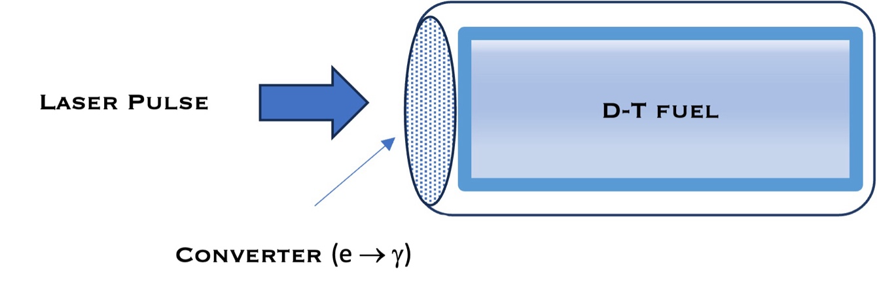

**Figure 1.** Scheme of the D-T fuel burning in a Z-pinch device using laser ignition

The burning rate of D-T fuel in Z-pinch devices with magneto-inertial fusion is investigated in this paper. Specifically, only deuterium and tritium are contained in the liner of a pinch. Although deuterium-tritium (D-T) fuel is considered in the calculations, to achieve realistic results it is essential to take into account the densities of various charged ions produced during nuclear fusion reactions. The main process is the D-T fusion reaction with emission of α-particles and neutrons. However, despite the lower fusion cross section compared to D-T fusion, there is also a possibility of D-D and T-T fusion reactions, so that charged particles like protons, tritium and 3He ions can be additionally produced during fusion. Thus, the following reactions have been used for accurate and precise calculations:

$$\begin{aligned}D+T→n+{}_{ }^{4}{He}+17.59,\#\left(1\right)\end{aligned}$$

$$\begin{aligned}D+D→p+T+4.03,\#\left(2\right)\end{aligned}$$

$$\begin{aligned}D+D→n+{}_{ }^{3}{He}+3.27,\#\left(3\right)\end{aligned}$$

$$\begin{aligned}D+{}_{ }^{3}{He}→p+{}_{ }^{4}{He}+18.35,\#\left(4\right)\end{aligned}$$

$$\begin{aligned}T+T→n+n+{}_{ }^{4}{He}+11.33,\#\left(5\right)\end{aligned}$$

$$\begin{aligned}{}_{ }^{3}{He}+{}_{ }^{3}{He}→p+p+{}_{ }^{4}{He}+12.86,\#(6)\end{aligned}$$

where the reaction energies (*Q* values) are expressed in units of MeV.

The burning rate of thermonuclear fusion fuel is influenced by different factors: the fuel type, the electron and ion densities and temperatures, and the fusion cross sections of light nuclei contained and produced in a fuel mixture. Among the nuclear reactions given in Equations (1)-(6), the D-T fusion reaction has the largest cross section, which has a broad maximum at a center-of-mass energy of 64 keV [27]. The D-T and D-3He fusion reactions are resonant [28,29], while the D-D, T-T, and 3He-3He fusion reactions have a non-resonant nature. As a result, due to a wide resonance, the D-T and D-3He fusion reactions have higher fusion cross sections compared to the other reactions.

Although fusion cross sections significantly influence the burning rate of fuel, it is essential to take into account the fact that particles in plasma are distributed depending on their velocities (kinetic energies). Therefore, a more principal physical value for nuclear fusion is the reaction rate. Assuming the Maxwellian distribution of particles, the thermally averaged reaction rate can be obtained as follows [30]

$$\begin{aligned}〈συ〉\left(T\right)=\int_{0}^{∞}{σ\left(E\right)f_{Maxw}\left(υ\right)υdυ},\#\left(7\right)\end{aligned}$$

where $σ\left(E\right)$ is the fusion cross section, $υ$ is the particle velocity, and $f_{Maxw}\left(υ\right)$ is the Maxwellian distribution function.

In this paper, the reaction rates obtained by the approximation formulas [30,31] were utilized. The logarithmic reaction rates for the reactions from Equations (1)-(4) were taken from [30] and expressed as

$$\begin{aligned}\log{〈συ〉\left(T\right)}=\sum_{k=0}^{6}{\left(ξ_{k}\cos{kt}+η_{k}\sin{kt}\right)}, t=\frac{π}{30}\left(\log{T}-3.65\right), 1.0≤\log{T}≤6.3,\#\left(8\right)\end{aligned}$$

where the temperature $T$ is expressed in untis of eV. The approximation coefficients $ξ_{k}$ and $η_{k}$ are defined and listed in [30].

The reaction rates for the reactions corresponding to Equations (5)-(6) were obtained from the approximation formulas [31] as follows

$$\begin{aligned}{〈συ〉}_{TT}\left(T\right)≈5.41×{10}^{-14}T^{{-2}/3}\exp\left(-\frac{21.52}{T^{1/3}}\right),\#\left(9\right)\end{aligned}$$

$$\begin{aligned}{〈συ〉}_{{}_{ }^{3}{He}{}_{ }^{3}{He}}\left(T\right)≈1.93×{10}^{-12}T^{-2/3}\exp\left(-\frac{54.22}{T^{1/3}}\right),\#\left(10\right)\end{aligned}$$

where the temperature $T$ is expressed in keV. The reaction rates in Equations (8)-(11) are expressed in units of cm3/s.

Figure 2 shows the reaction rate values of the nuclear reactions corresponding to Equations (1)-(6) depending on temperatures in the center-of-mass energy frame, obtained by the parametrization formulas given in Equations (8)-(11). From the results illustrated in Figure 2, it can be noted that the reaction rate of the D-T fusion reaction is dominant compared to other reactions at temperatures up to 1000 keV, while that of D-3He is the second highest from 10 keV and above. However, at higher temperatures, the reaction rates of other processes significantly increase and approach the values of the deuterium-tritium fusion reaction. At lower energies, up to 10 keV, the T-T fusion reaction rate is slightly lower than that of D-D fusion (nuclear reactions (2) and (3) are considered separately), but almost equal from 10 keV to 200 keV. Additionally, the reaction rate of the 3He-3He fusion is the lowest among all reactions considered in this paper.

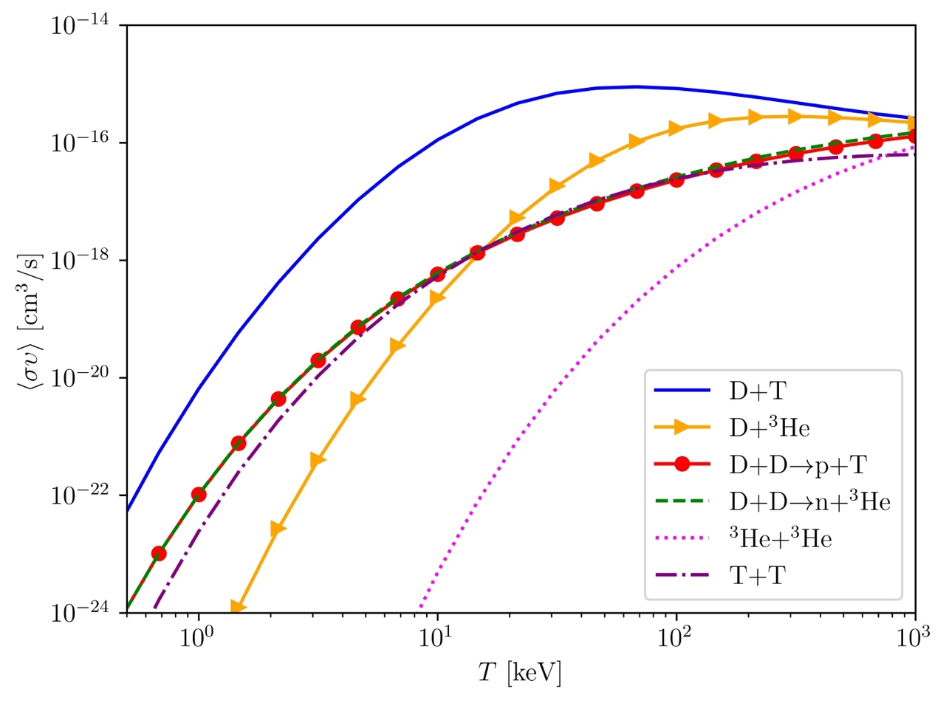

**Figure 2.** Reaction rates of the main fusion reactions as functions of temperature

The burning rate of the D-T fusion in a dense hot plasma is defined through a set of particle and energy balance equations, which involve the reaction rates depending on the plasma temperature. The particle balance equations describe the change in the ion densities of fuel components. Initially, the fuel mixture contains only deuterium and tritium ions and electrons. As a result of the fusion reactions, the fuel mixture is filled with protons, 3He, and 4He ions. Thus, based on the rates of fusion reactions corresponding to Equations (1)-(6), the set of particle balance equations can be defined as follows

$$\begin{aligned}\frac{{dn}_{p}}{dt}=\frac{1}{2}n_{d}^{2}{〈συ〉}_{DDp}+n_{D}n_{{}_{ }^{3}{He}}{〈συ〉}_{D{}_{ }^{3}{He}}+n_{{}_{ }^{3}{He}}^{2}{〈συ〉}_{{}_{ }^{3}{He{}_{ }^{3}{He}}},\#\left(11\right)\end{aligned}$$

$$\begin{aligned}\frac{dn_{D}}{dt}=-n_{D}^{2}{〈συ〉}_{DDp}-{n_{D}^{2}〈συ〉}_{DDn}-n_{D}n_{T}{〈συ〉}_{DT}-{n_{D}n_{{}_{ }^{3}{He}}〈συ〉}_{D{}_{ }^{3}{He}},\#\left(12\right)\end{aligned}$$

$$\begin{aligned}\frac{dn_{T}}{dt}=\frac{1}{2}{n_{D}^{2}〈συ〉}_{DDp}-n_{D}n_{T}{〈συ〉}_{DT}-n_{T}^{2}{〈συ〉}_{TT},\#\left(13\right)\end{aligned}$$

$$\begin{aligned}\frac{dn_{{}_{ }^{3}{He}}}{dt}=\frac{1}{2}n_{D}^{2}{〈συ〉}_{DDn}-n_{D}n_{{}_{ }^{3}{He}}{〈συ〉}_{D{}_{ }^{3}{He}}-n_{{}_{ }^{3}{He}}^{2}{〈συ〉}_{{}_{ }^{3}{He}{}_{ }^{3}{He}},\#\left(14\right)\end{aligned}$$

$$\begin{aligned}\frac{dn_{α}}{dt}=n_{D}n_{T}{〈συ〉}_{DT}+n_{D}n_{{}_{ }^{3}{He}}{〈συ〉}_{D{}_{ }^{3}{He}}+\frac{1}{2}n_{T}^{2}{〈συ〉}_{TT}+\frac{1}{2}n_{{}_{ }^{3}{He}}^{2}{〈συ〉}_{{}_{ }^{3}{He}{}_{ }^{3}{He}},\#\left(15\right)\end{aligned}$$

where $n_{i}$ is the density of the *i*-th ion (*i* = p, D, T, 3He, α), and ${〈συ〉}_{ij}$ is the fusion reaction rate for reactions (1)-(6). The rates of reactions of identical particles are multiplied by a factor of 1/2. It should be noted that in Equations (11)-(15), the particle number is taken into account, not reactions. Thus, for example, in Equation (12), since two deuterium nuclei are lost during the D-D fusion reactions, the number of particles is proportional to ${〈συ〉}_{DDp}$ and ${〈συ〉}_{DDn}$, while the corresponding reaction rates are $\frac{1}{2}{〈συ〉}_{DDp}$ and $\frac{1}{2}{〈συ〉}_{DDn}$. Similarly, the formation of 2 protons in reaction in Equation (6) is taken into account, as well as the loss of 2 tritium/helium-3 nuclei in reactions corresponding to Equations (5)-(6).

The total energy density of a plasma depends on the kinetic energies of both electrons and ions. Generally, the temperatures of electrons and ions are different. Moreover, in a fuel mixture there are different hydrogen and helium ions as well as other impurities in the plasma. In addition, it is worth noting that the plasma temperature is primarily influenced by the charged ions. Thus, assuming equal average ion and electron temperatures, the total energy density $E_{tot}$ can be obtained as follows

$$\begin{aligned}E_{tot}=\frac{3}{2}\left[n_{e}〈T_{e}〉+\sum_{i}{n_{i}}〈T_{i}〉\right]=\frac{3}{2}\left(n_{e}+n_{p}+n_{D}+n_{T}+n_{{}_{ }^{3}{He}}+n_{α}\right)〈T_{i}〉,\#\left(16\right)\end{aligned}$$

where $n_{e}$ is the electron density, $〈T_{e}〉$ is the average electron temperature, and $〈T_{i}〉$ is the average ion temperature. In terms of the quasi-neutrality condition for the plasma, the electron density is defined as

$$\begin{aligned}n_{e}=\sum_{i}{Z_{i}n_{i}}=n_{p}+n_{D}+n_{T}+{2n}_{{}_{ }^{3}{He}}+{2n}_{α},\#\left(17\right)\end{aligned}$$

where $Z_{i}$ and $n_{i}$ are the charge and the density of the *i*-th ion, respectively.

The energy balance equation shows the difference between the fusion power density and radiation losses, and can be defined for Z-pinch devices with magneto-inertial confinement in the following way

$$\begin{aligned}\frac{dE_{tot}}{dt}=P_{ch}-P_{br}-P_{syn},\#\left(18\right)\end{aligned}$$

where $P_{ch}$ is the fusion power density of charged ions, $P_{br}$ is the bremsstrahlung radiation power density loss, $P_{syn}$ is the the synchrotron radiation power density loss. Since the electromagnetic fields, which compress and confine the plasma in a Z-pinch configuration, are generated by the plasma itself, no external resources are needed. Thus, auxiliary power is not essential, except for laser ignition, which is required for the plasma to achieve a minimum fusion temperature of 10 keV. In fact, the temperature of a 10 keV is chosen as initial for the calculations in this paper. In addition, taking into account that the magnetic field is strong, we may assume that the transport losses can be neglected. Therefore, in a Z-pinch device there is only thermonuclear energy from charged hydrogen and helium ions, partially emitting as the bremsstrahlung radiation. In addition, we consider the central (hottest) areas of the plasma in Z-pinch devices, which are not affected by the synchrotron radiation. Therefore, the synchrotron radiation power density loss can be neglected.

The fusion power density, based on the energy yield of charged particles in reactions (1)-(6), is obtained as

$$\begin{aligned}P_{ch}=n_{D}n_{T}{〈συ〉}_{DT}E_{α\left(DT\right)}+\frac{1}{2}n_{D}^{2}{〈συ〉}_{DDp}Q_{DDp}+\frac{1}{2}n_{D}^{2}{〈συ〉}_{DDn}E_{{}_{ }^{3}{He}} \\ +n_{D}n_{{}_{ }^{3}{He}}{〈συ〉}_{D{}_{ }^{3}{He}}Q_{D{}_{ }^{3}{He}}+\frac{1}{2}n_{T}^{2}{〈συ〉}_{TT}E_{α\left(TT\right)}+\frac{1}{2}n_{{}_{ }^{3}{He}}^{2}{〈συ〉}_{{}_{ }^{3}{He}{}_{ }^{3}{He}}Q_{{}_{ }^{3}{He}{}_{ }^{3}{He}},\#\left(19\right)\end{aligned}$$

where $Q_{ij}$ is the reaction energy (*Q* value), $E_{i}$ is the kinetic energy of a charged particle. Here, the values of energy densities are expressed in MeV/cm3. It is worth noting that the full fusion power density is the sum of the power densities of charged ions and neutrons. However, as mentioned before, the plasma temperature is affected only by the fusion power of charged ions.

The fusion power density of neutrons is defined as follows

$$\begin{aligned}P_{n}=n_{D}n_{T}{〈συ〉}_{DT}E_{n\left(DT\right)}+\frac{1}{2}n_{D}^{2}{〈συ〉}_{DDn}E_{n\left(DDn\right)}+\frac{1}{2}n_{T}^{2}{〈συ〉}_{TT}\left(E_{n_{1}\left(TT\right)}+E_{n_{2}\left(TT\right)}\right),\#\left(20\right)\end{aligned}$$

where $E_{n\left(DT\right)}$, $E_{n\left(DDn\right)}$, $E_{n_{1}\left(TT\right)}$, $E_{n_{2}\left(TT\right)}$ are the kinetic energies of the neutrons from the fusion reactions corresponding to Equations (1), (3), (5).

The bremsstrahlung radiation power loss is defined as follows [32]

$$\begin{aligned}P_{br}=0.343283×{10}^{-17}n_{e}{〈T_{e}〉}^{1/2}\sum_{i}{n_{i}Z_{i}^{2}},\#\left(21\right)\end{aligned}$$

Here, the power density loss is measured in MeV/cm3.

The set of particle and energy balance equations (11)-(18) was solved numerically using general integration of ordinary differential equations, employing the SciPy module in Python [33].

Results and Discussion

Figure 3 shows the time-dependent changes in ion densities and plasma temperature during D-T fuel burning in a Z-pinch device with magneto-inertial confinement, which correspond to the numerical results from Equations (11)-(18). The initial fuel mixture contained only deuterium and tritium atoms. The initial densities of deuterium and tritium were chosen equal to cm-3. Taking into account the quasi-neutrality condition for the plasma, the density of electrons was equal to cm-3. The full burning time of the D-T fuel reached $2.6×{10}^{-8}$ seconds. The plasma temperature increased rapidly achieving the maximum of 300.38 keV in $0.494×{10}^{-8}$ seconds. As expected, since the cross-section of the D-T fusion is dominant among other fusion reactions, the number of produced alpha-particles exceeded the number of other produced ions during the burning. As a result of a fast growth of the temperature, the reactions (2)-(6) influenced significantly the burning rate of the D-T fuel, increasing the production of charged ions, especially protons and 3He ions, and further burning of the produced deuterium and tritium ions. From the results illustrated in Figure 3, it is worth noting that the effective burning time reached the value of $2.2×{10}^{-8}$ seconds, and throughout the remaining burning time the plasma temperature dramatically dropped to 0 keV, thereby causing the stop of the fusion process.

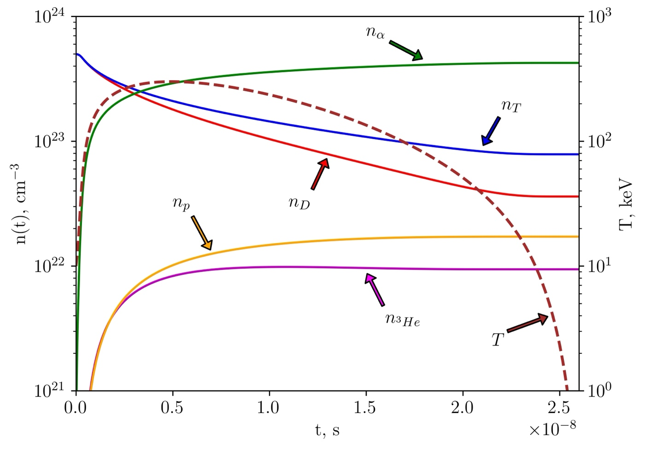

**Figure 5.** The time-dependent change in ion densities and plasma temperature during D-T fuel burning in a Z-pinch device

Figure 4 illustrates the energy yield of charged ions, neutrons, and bremsstrahlung radiation produced from the D-T fuel burning process per unit of volume depending on time. As a result of the fast growth of the plasma temperature, the energy yield of charged ions and neutrons increased significantly reaching a maximum of MeV/cm3 and MeV/cm3, respectively, in $3.33×{10}^{-10}$ seconds. The bremsstrahlung radiation grew rapidly up to MeV/cm3 in seconds and gradually decreased down to 0 MeV/cm3 over the burning time. From the results presented in Figure 4 it can be concluded that in a Z-pinch device the burning of the D-T fuel is characterized with effective ultrafast ignition in nanoseconds and gradual decrease of an energy yield over the burning period. In addition, neutrons produce more energy than charged ions during the D-T fuel burning, since 80% of the kinetic energy in reaction (1) goes to neutrons, and only 20% goes to alpha-particles.

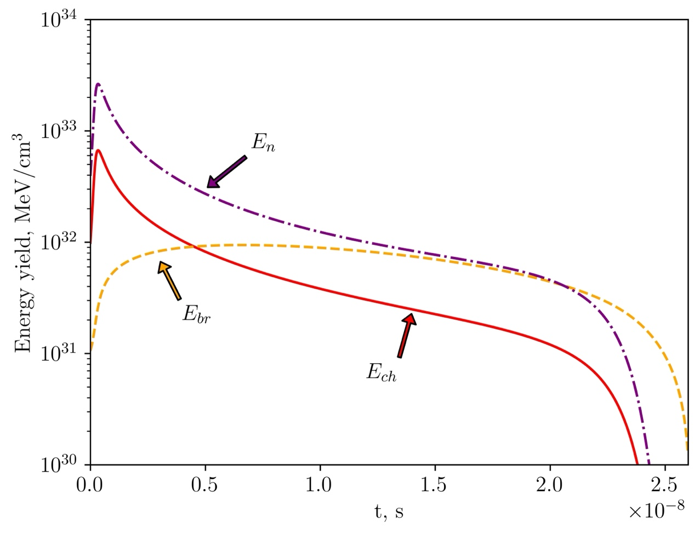

**Figure 4.** Energy yield per unit of volume for the D-T fuel burning

**Conclusions**

**Author Contributions:** Conceptualization, O.B..; methodology, O.B.; software, A.A.; formal analysis, O.B.; investigation, O.B., A.A.; resources, O.B., A.A.; writing—original draft preparation, O.B.; writing—review and editing, O.B.; visualization, O.B., A.A.; supervision, O.B.; project administration, O.B.; funding acquisition, O.B. All authors have read and agreed to the published version of the manuscript.

**Funding:** This research was funded by the Science Committee of the Ministry of Education and Science of the Republic of Kazakhstan (Grant No. AP14871936).

**Data Availability Statement:** Data is contained within the article.

**Conflicts of Interest:** The authors declare no conflict of interest.

**References**

1. Meschini, S.; Laviano, F.; Ledda, F.; Pettinari, D.; Testoni, R.; Torsello, D.; Panella, B. Review of Commercial Nuclear Fusion Projects. *Front. Energy Res.* **2023**, *11*, 1157394, doi:10.3389/fenrg.2023.1157394.

2. Banacloche, S.; Gamarra, A.R.; Lechon, Y.; Bustreo, C. Socioeconomic and Environmental Impacts of Bringing the Sun to Earth: A Sustainability Analysis of a Fusion Power Plant Deployment. *Energy* **2020**, *209*, 118460, doi:10.1016/j.energy.2020.118460.

3. Ryzhkov, S.V. Magneto-Inertial Fusion and Powerful Plasma Installations (A Review). *Applied Sciences* **2023**, *13*, 6658, doi:10.3390/app13116658.

4. Snipes, J.A.; Vries, P.C. de; Gribov, Y.; Henderson, M.A.; Hunt, R.; Loarte, A.; Nunes, I.; Pitts, R.A.; Sinha, J.; Zabeo, L.; et al. ITER Plasma Control System Final Design and Preparation for First Plasma. *Nucl. Fusion* **2021**, *61*, 106036, doi:10.1088/1741-4326/ac2339.

5. Maslov, M.; Lerche, E.; Auriemma, F.; Belli, E.; Bourdelle, C.; Challis, C.D.; Chomiczewska, A.; Molin, A.D.; Eriksson, J.; Garcia, J.; et al. JET D-T Scenario with Optimized Non-Thermal Fusion. *Nucl. Fusion* **2023**, *63*, 112002, doi:10.1088/1741-4326/ace2d8.

6. Hasegawa, A. ITER and the Prospects for Commercial Fusion. *Physics Today* **2020**, *73*, 10–11, doi:10.1063/PT.3.4511.

7. Huang, C.; Li, L. Magnetic Confinement Fusion: A Brief Review. *Front. Energy* **2018**, *12*, 305–313, doi:10.1007/s11708-018-0539-1.

8. Craxton, R.S.; Anderson, K.S.; Boehly, T.R.; Goncharov, V.N.; Harding, D.R.; Knauer, J.P.; McCrory, R.L.; McKenty, P.W.; Meyerhofer, D.D.; Myatt, J.F.; et al. Direct-Drive Inertial Confinement Fusion: A Review. *Physics of Plasmas* **2015**, *22*, 110501, doi:10.1063/1.4934714.

9. Ruskov, E.; Ney, P.; Rahman, H.U. The Staged Z-Pinch as a Potential Fusion Energy Source. *Physics of Plasmas* **2020**, *27*, 042709, doi:10.1063/1.5131770.

10. Gomez, M.R.; Slutz, S.A.; Jennings, C.A.; Weis, M.R.; Lamppa, D.C.; Harvey-Thompson, A.J.; Geissel, M.; Awe, T.J.; Chandler, G.A.; Crabtree, J.A.; et al. Developing a Platform to Enable Parameter Scaling Studies in Magnetized Liner Inertial Fusion Experiments. In Proceedings of the 2021 IEEE International Conference on Plasma Science (ICOPS); September 2021; pp. 1–1.

11. Yager-Elorriaga, D.A.; Gomez, M.R.; Ruiz, D.E.; Slutz, S.A.; Harvey-Thompson, A.J.; Jennings, C.A.; Knapp, P.F.; Schmit, P.F.; Weis, M.R.; Awe, T.J.; et al. An Overview of Magneto-Inertial Fusion on the Z Machine at Sandia National Laboratories. *Nucl. Fusion* **2022**, *62*, 042015, doi:10.1088/1741-4326/ac2dbe.

12. Sinars, D.B.; Sweeney, M.A.; Alexander, C.S.; Ampleford, D.J.; Ao, T.; Apruzese, J.P.; Aragon, C.; Armstrong, D.J.; Austin, K.N.; Awe, T.J.; et al. Review of Pulsed Power-Driven High Energy Density Physics Research on Z at Sandia. *Physics of Plasmas* **2020**, *27*, 070501, doi:10.1063/5.0007476.

13. Wessel, F.J.; Ur-Rahman, H.; Ney, P.; Presura, R. Fusion in a Staged $Z$ -Pinch. *IEEE Trans. Plasma Sci.* **2015**, *43*, 2463–2468, doi:10.1109/TPS.2015.2433796.

14. Seyler, C.E.; Martin, M.R.; Hamlin, N.D. Helical Instability in MagLIF Due to Axial Flux Compression by Low-Density Plasma. *Physics of Plasmas* **2018**, *25*, 062711, doi:10.1063/1.5028365.

15. Rahman, H.U.; Wessel, F.J.; Rostoker, N.; Ney, P.H. High Yield Fusion in a Staged Z-Pinch. *J. Plasma Phys.* **2009**, *75*, 749–768, doi:10.1017/S002237780900796X.

16. Shumlak, U.; Nelson, B.A.; Claveau, E.L.; Forbes, E.G.; Golingo, R.P.; Hughes, M.C.; Oberto, R.J.; Ross, M.P.; Weber, T.R. Increasing Plasma Parameters Using Sheared Flow Stabilization of a Z-Pinch. *Physics of Plasmas* **2017**, *24*, 055702, doi:10.1063/1.4977468.

17. Forbes, E.G.; Shumlak, U.; McLean, H.S.; Nelson, B.A.; Claveau, E.L.; Golingo, R.P.; Higginson, D.P.; Mitrani, J.M.; Stepanov, A.D.; Tummel, K.K.; et al. Progress Toward a Compact Fusion Reactor Using the Sheared-Flow-Stabilized Z-Pinch. *Fusion Science and Technology* **2019**, *75*, 599–607, doi:10.1080/15361055.2019.1622971.

18. Shumlak, U. Z-Pinch Fusion. *Journal of Applied Physics* **2020**, *127*, 200901, doi:10.1063/5.0004228.

19. Xu, K.; Qi, C.; Wang, B. Recent Progress in Research of Solid Tritium Breeder Materials Li2TiO3: A Review. *Coatings* **2022**, *12*, 1053, doi:10.3390/coatings12081053.

20. Abdou, M.; Riva, M.; Ying, A.; Day, C.; Loarte, A.; Baylor, L.R.; Humrickhouse, P.; Fuerst, T.F.; Cho, S. Physics and Technology Considerations for the Deuterium–Tritium Fuel Cycle and Conditions for Tritium Fuel Self Sufficiency. *Nucl. Fusion* **2021**, *61*, 013001, doi:10.1088/1741-4326/abbf35.

21. Ananyev, S.S.; Spitsyn, A.V.; Kuteev, B.V. Concept of DT Fuel Cycle for a Fusion Neutron Source DEMO-FNS. *Fusion Engineering and Design* **2016**, *109–111*, 57–60, doi:10.1016/j.fusengdes.2016.03.053.

22. Spagnuolo, G.A.; Arredondo, R.; Boccaccini, L.V.; Coleman, M.; Cristescu, I.; Federici, G.; Franza, F.; Garcinuño, B.; Moreno, C.; Rapisarda, D.; et al. Integration Issues on Tritium Management of the European DEMO Breeding Blanket and Ancillary Systems. *Fusion Engineering and Design* **2021**, *171*, 112573, doi:10.1016/j.fusengdes.2021.112573.

23. Cristescu, I.; Priester, F.; Rapisarda, D.; Santucci, A.; Utili, M. Overview of the Tritium Technologies for the EU DEMO Breeding Blanket. *Fusion Science and Technology* **2020**, *76*, 446–457, doi:10.1080/15361055.2020.1716456.

24. Mazzucato, E. A D-3He Fusion Reactor for the Mitigation of Global Warming. *Fundamental Plasma Physics* **2023**, *6*, 100022, doi:10.1016/j.fpp.2023.100022.

25. Voronchev, V.T.; Kukulin, V.I. Implementation of the Thermonuclear Process in D3He-9Be Plasma on the Basis of a Z Pinch with an Ultrafast Laser Ignition. *Phys. Atom. Nuclei* **2010**, *73*, 38–58, doi:10.1134/S1063778810010060.

26. Seksembayev, Z.; Kukulin, V.; Sakhiyev, S. Study of a Dense Hot Plasma’s Burning in *Z* -Pinch Devices with Inertial-Magnetic Confinement. *Phys. Scr.* **2018**, *93*, 085602, doi:10.1088/1402-4896/aacadf.

27. Atzeni, S.; Meyer-Ter-Vehn, Jü. Nuclear Fusion Reactions. In *The Physics of Inertial Fusion: BeamPlasma Interaction, Hydrodynamics, Hot Dense Matter*; Atzeni, S., Meyer-ter-Vehn, J., Eds.; Oxford University Press, 2004; p. 0 ISBN 978-0-19-856264-1.

28. De Souza, R.S.; Boston, S.R.; Coc, A.; Iliadis, C. Thermonuclear Fusion Rates for Tritium + Deuterium Using Bayesian Methods. *Phys. Rev. C* **2019**, *99*, 014619, doi:10.1103/PhysRevC.99.014619.

29. De Souza, R.S.; Iliadis, C.; Coc, A. Astrophysical S-Factors, Thermonuclear Rates, and Electron Screening Potential for the 3 He(d,p) 4 He Big Bang Reaction via a Hierarchical Bayesian Model. *ApJ* **2019**, *872*, 75, doi:10.3847/1538-4357/aafda9.

30. Belov, A.A.; Kalitkin, N.N.; Kozlitin, I.A. Refinement of Thermonuclear Reaction Rates. *Fusion Engineering and Design* **2019**, *141*, 51–58, doi:10.1016/j.fusengdes.2019.02.082.

31. Fowler, W.A.; Caughlan, G.R.; Zimmerman, B.A. Thermonuclear Reaction Rates, II. *Annual Review of Astronomy and Astrophysics* **1975**, *13*, 69, doi:10.1146/annurev.aa.13.090175.000441.

32. Graber, V.; Schuster, E. Assessment of the Burning-Plasma Operational Space in ITER by Using a Control-Oriented Core-SOL-Divertor Model. *Fusion Engineering and Design* **2021**, *171*, 112516, doi:10.1016/j.fusengdes.2021.112516.

33. Oliphant, T.E. Python for Scientific Computing. *Comput. Sci. Eng.* **2007**, *9*, 10–20, doi:10.1109/MCSE.2007.58.